# AMERICAN INTERNATIONAL UNIVERSITY BANGLADESH

Faculty of Engineering

# Laboratory Report Cover Sheet

***Students must complete all details except the faculty use part.***

Please submit all reports to your subject supervisor or the office of the concerned faculty.

Lab Title: **Frequency Division Multiplexing using MATLAB**

Experiment Number: **09** Due Date: **03 /05/2024** Semester: **Spring 2023-2024** Subject Code: **COE3103** Subject Name: **DATA COMMUNICATION** Section: **E** Course Instructor: **NOWSHIN ALAM** Degree Program: **B.Sc. CSE**

## Declaration and Statement of Authorship:

1. I/we hold a copy of this report, which can be produced if the original is lost/ damaged.
2. This report is my/our original work and no part of it has been copied from any other student’s work or from any other source except where due acknowledgement is made.
3. No part of this report has been written for me/us by any other person except where such collaboration has been authorized by the lecturer/teacher concerned and is clearly acknowledged in the report.
4. I/we have not previously submitted or currently submitting this work for any other course/unit.
5. This work may be reproduced, communicated, compared and archived for the purpose of detecting plagiarism.
6. I/we give permission for a copy of my/our marked work to be retained by the school for review and comparison, including review by external examiners.

## I/we understand that

1. Plagiarism is the presentation of the work, idea or creation of another person as though it is your own. It is a form of cheating and is a very serious academic offence that may lead to expulsion from the University. Plagiarized material can be drawn from, and presented in, written, graphic and visual form, including electronic data, and oral presentations. Plagiarism occurs when the origin of the material used is not appropriately cited.
2. Enabling plagiarism is the act of assisting or allowing another person to plagiarize or to copy your work.

|  |  |  |  |  |  |  |  |  |  |  |  |  |
| --- | --- | --- | --- | --- | --- | --- | --- | --- | --- | --- | --- | --- |
| Group Number (if applicable): 8 | | | Individual Submission | | |  | Group Submission | | |  |  |  |
|  | | | | | | | | | | |  |
| **No.** |  | **Student Name** | | **Student Number** |  |  | **Student Signature** |  | **Date** | |  |
| **Submitted by:** | | | | | | | | | | |  |
| **1** | | **KHUSHBU ALAM RAHI** | | **22-46947-1** | |  | | |  | |  |
| ***For faculty use only:*** | | | | **Total Marks: Marks Obtained:** | | | | | | |  |  |
| **Faculty comments** | | | | | | | | | | |  |
|  | | | | | | | | | |  |  |

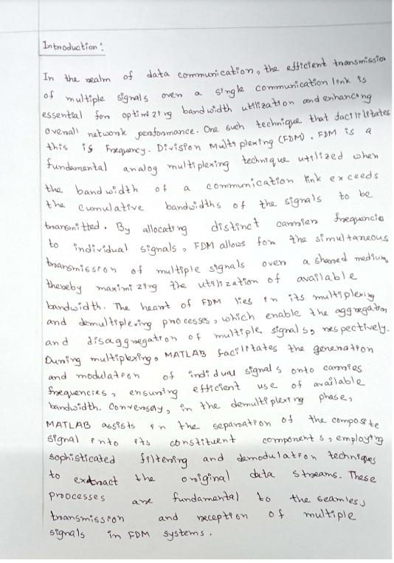

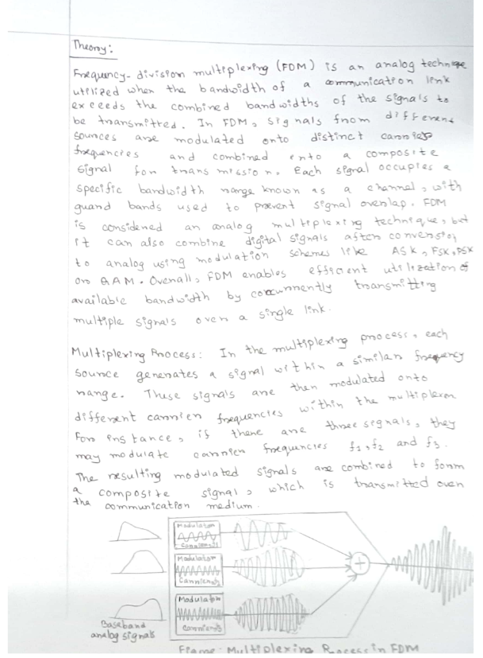

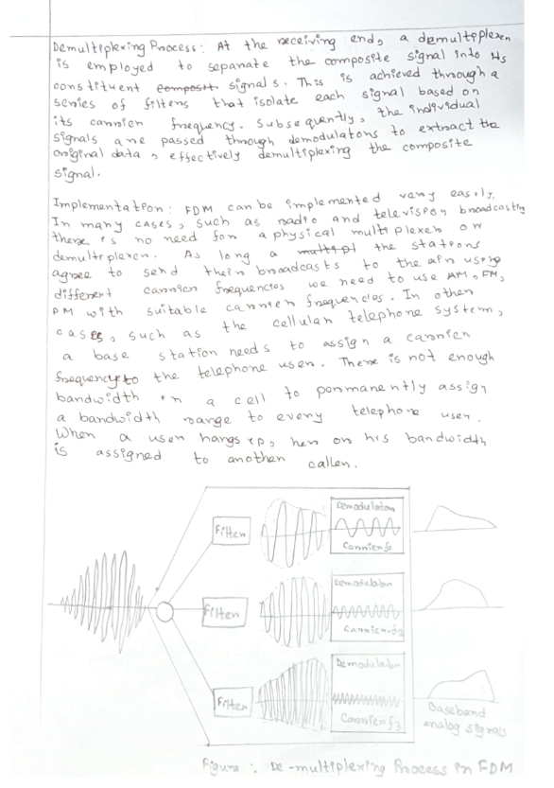

**Simulated Results:**ID=AB-CDEFG-H  
ID=22-46947-1  
  
There are four message signals:

a) mt1 = am1*cos(2*pi*fm1*t);

b) mt2 = am2*cos(2*pi*fm2*t);

c) mt3 = am3*cos(2*pi*fm3*t);

d) mt4 = am4*cos(2*pi*fm4*t);

where,

am1 = (F+2);

am2 = (F+5);

am3 = (F+8);

am4 = (F+11);

and

fm1 = (G+1);

fm2 = (G+2);

fm3 = (G+3);

fm4 = (G+4);  
**Code and Simulations:**Simultaneous transmission of these four signals through a single data link supporting a frequency range of 50 Hz to 250 Hz is achieved by employing frequency division multiplexing (FDM).

clc

clear all

close all

%ID=AB-CDEFG-H

%ID=22-46947-1

fs = 4001; %Sampling Frequency

t = 0:1/fs:1-1/fs; %Generating Time axis

%am1 = (F+2)

%am1=(4+2)=6

am1 = 6; %Amplitude of First Message Signal

%fm1 = (G+1)=(7+1)=8;

fm1 = 8; %Frequency of First Message Signal

m1 = am1*cos(2*pi*fm1*t); % First Message Signal

%am2 = (F+5)=(4+5)=9;

am2 = 9; %Amplitude of Second Message Signal

%fm2 = (G+2)=(7+2)=9;

fm2 = 9; %Frequency of Second Message Signal

m2 = am2*cos(2*pi*fm2*t); % Second Message Signal

%am3 = (F+8)=(4+8)=12;

am3 = 12; %Amplitude of Third Message Signal

%fm3 = (G+3)=(7+3)=10;

fm3 = 10; %Frequency of Third Message Signal

m3 = am3*cos(2*pi*fm3*t); % Third Message Signal

%am4 = (F+11)=(4+11)=15;

am4=15;

%fm4 = (G+4)=(7+4)=11;

fm4=11;

m4 = am4*cos(2*pi*fm4*t); % Fourth Message Signal

%%

%% Carrier Signal Generation

Cm1 = 1; %Amplitude of First Carrier Signal

fc1 = 80; %Frequency of First Carrier Signal

c1 = Cm1*cos(2*pi*fc1*t); % First Carrier Signal

Cm2 = 1; %Amplitude of Second Carrier Signal

fc2 = 130; %Frequency of Second Carrier Signal  
c2 = Cm2*cos(2*pi*fc2*t); % Second Carrier Signal

Cm3 = 1; %Amplitude of Third Carrier Signal

fc3 = 180; %Frequency of Third Carrier Signal

c3 = Cm3*cos(2*pi*fc3*t); % Third Carrier Signal

Cm4 = 1; %Amplitude of Fourth Carrier Signal

fc4 = 220; %Frequency of Fourth Carrier Signal

c4 = Cm4*cos(2*pi*fc4*t); % Fourth Carrier Signal

%%

%% Composite Signal Generation

x = (m1).*c1+(m2).*c2+(m3).*c3+(m4).*c4;

%%%% Plotting the Signals in Time-Domain and Frequency-Domain

figure

subplot(4,1,1)

plot(t,m1)

xlabel('time')

ylabel('amplitude')

title('Message Signal 1 in Time Domain')

ylim([-am1 am1])

subplot(4,1,2)

plot(t,m2)

xlabel('time')

ylabel('amplitude')

title('Message Signal 2 in Time Domain')

ylim([-am2 am2])

subplot(4,1,3)

plot(t,m3)

xlabel('time')

ylabel('amplitude')

title('Message Signal 3 in Time Domain')

ylim([-am3 am3])

subplot(4,1,4)

plot(t,m4)

xlabel('time')

ylabel('amplitude')

title('Message Signal 4 in Time Domain')

ylim([-am4 am4])

M1 = abs(fftshift(fft(m1)))/(fs/2); %Fourier Transformation of m1

M2 = abs(fftshift(fft(m2)))/(fs/2); %Fourier Transformation of m2

M3 = abs(fftshift(fft(m3)))/(fs/2); %Fourier Transformation of m3

M4 = abs(fftshift(fft(m4)))/(fs/2); %Fourier Transformation of m4

X = abs(fftshift(fft(x)))/(fs/2); %Fourier Transformation of x

f = fs/2*linspace(-1,1,fs);

figure

subplot(4,1,1)

stem(f,M1)

xlabel('frequency')

ylabel('amplitude')

title('Message Signal 1 in Frequency Domain')

axis([-15 15 0 10])

subplot(4,1,2)

stem(f,M2)

xlabel('frequency')

ylabel('amplitude')

title('Message Signal 2 in Frequency Domain')

axis([-15 15 0 10])

subplot(4,1,3)

stem(f,M3)

xlabel('frequency')

ylabel('amplitude')

title('Message Signal 3 in Frequency Domain')

axis([-15 15 0 16])

subplot(4,1,4)

stem(f,M4)

xlabel('frequency')

ylabel('amplitude')

title('Message Signal 4 in Frequency Domain')

axis([-15 15 0 18])

figure

subplot(2,1,1)

plot(t,x)

xlabel('time')

ylabel('amplitude')

title('Composite Signal in Time Domain')

subplot(2,1,2)

stem(f,X)

xlabel('frequency')

ylabel('amplitude')

title('Composite Signal in Frequency Domain')

axis([-270 270 0 4.5])

%%

%% Passing the Composite Signal Through Bandpass Filter

[num1, den1] = butter(5, [(fc1-fm1-6)/(fs/2),(fc1+fm1+6)/(fs/2)]);

%Butterworth Filter Window Determining for Bandpass Filter

bpf1 = filter(num1,den1,x); %Filtering is done here

[num2, den2] = butter(5, [(fc2-fm2-6)/(fs/2),(fc2+fm2+6)/(fs/2)]);

%Butterworth Filter Window Determining for Bandpass Filter

bpf2 = filter(num2,den2,x); %Filtering is done here

[num3, den3] = butter(5, [(fc3-fm3-6)/(fs/2),(fc3+fm3+6)/(fs/2)]);

%Butterworth Filter Window Determining for Bandpass Filter

bpf3 = filter(num3,den3,x); %Filtering is done here

[num4, den4] = butter(5, [(fc4-fm4-6)/(fs/2),(fc4+fm4+6)/(fs/2)]);

%Butterworth Filter Window Determining for Bandpass Filter

bpf4 = filter(num4,den4,x); %Filtering is done here

%%

%% Mixing

z1 = 2*bpf1.*c1;

z2 = 2*bpf2.*c2;

z3 = 2*bpf3.*c3;

z4= 2*bpf4.*c4;

%%

%% Passing the Mixed Signals Through Lowpass Filter

[num5, den5] = butter(5, (fm1+3)/(fs/2)); %Low pass filter is made here

rec1 = filter(num5,den5,z1); %Filtering is done here

[num6, den6] = butter(5, (fm2+3)/(fs/2)); %Low pass filter is made here

rec2 = filter(num6,den6,z2); %Filtering is done here

[num7, den7] = butter(5, (fm3+3)/(fs/2)); %Low pass filter is made here

rec3 = filter(num7,den7,z3); %Filtering is done here

[num8, den8] = butter(5, (fm4+3)/(fs/2)); %Low pass filter is made here

rec4 = filter(num8,den8,z4); %Filtering is done here

%%

%% Plotting the Received Signals in Time-Domain and Frequency Domain

figure

subplot(4,1,1)

plot(t,rec1)

xlabel('time')

ylabel('amplitude')

title('received signal 1 in time domain')

ylim([-am1 am1])

subplot(4,1,2)

plot(t,rec2)

xlabel('time')

ylabel('amplitude')

title('received signal 2 in time domain')

ylim([-am2 am2])

subplot(4,1,3)

plot(t,rec3)

xlabel('time')

ylabel('amplitude')

title('received signal 3 in time domain')

ylim([-am3 am3])

subplot(4,1,4)

plot(t,rec4)

xlabel('time')

ylabel('amplitude')

title('received signal 4 in time domain')

ylim([-am4 am4])

R1 = abs(fftshift(fft(rec1)))/(fs/2); %Fourier Transformation is done here

R2 = abs(fftshift(fft(rec2)))/(fs/2); %Fourier Transformation is done here

R3 = abs(fftshift(fft(rec3)))/(fs/2); %Fourier Transformation is done here

R4 = abs(fftshift(fft(rec4)))/(fs/2); %Fourier Transformation is done here

figure

subplot(4,1,1)

stem(f,R1)

xlabel('frequency')

ylabel('amplitude')

title('received signal 1 in frequency domain')

xlim([-10 10])

subplot(4,1,2)

stem(f,R2)

xlabel('frequency')

ylabel('amplitude')

title('received signal 2 in frequency domain')

xlim([-10 10])

subplot(4,1,3)

stem(f,R3)

xlabel('frequency')

ylabel('amplitude')

title('received signal 3 in frequency domain')

xlim([-10 10])

subplot(4,1,4)

stem(f,R4)

xlabel('frequency')

ylabel('amplitude')

title('received signal 4 in frequency domain')

xlim([-10 10])

%% End

**Workspace:**

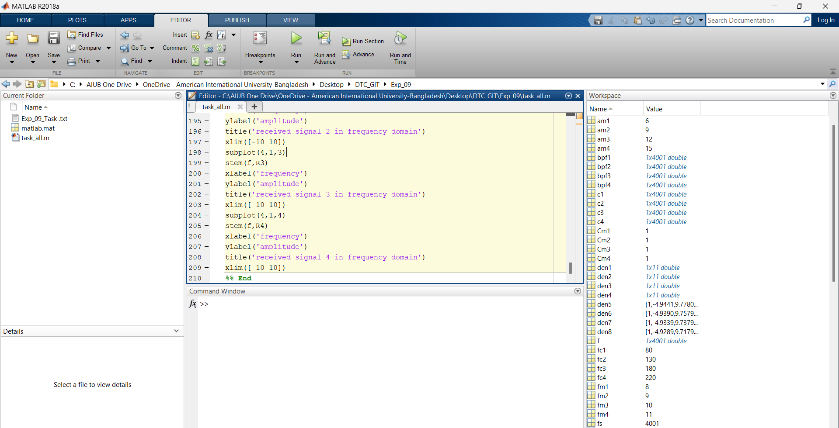

**Plots:** Figure 1: Message Signals in Time Domain

Figure 2: Message Signals in Frequency Domain

Figure 3: Composite Signal in Time Domain  
 and  
 Composite Signal in Frequency Domain  
  
 Figure 4: Received Signals in Time Domain  
 Figure 5: Received Signals in Frequency Domain   
  


